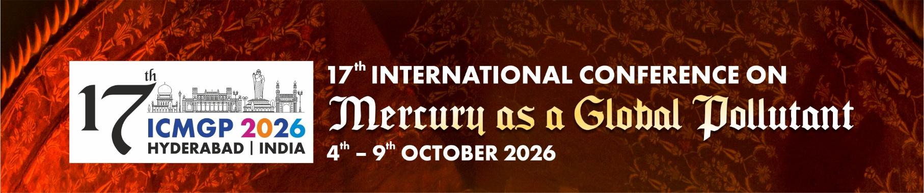

WORKSHOP MINI-PROPOSAL FORM
17th ICMGP – Hyderabad, India
Due Date: 28th February 2026

- LEAD / CO-LEAD PRESENTERS (ADD ADDITIONAL ROWS IF >3 PRESENTERS)

Lead Presenter Information
Name & Surname
Title or Designation
Organisation
Email address
Presenter Affiliations / Biographies
Please add website link of affiliation / biography

Co-Lead Presenter Information
Name & Surname
Title or Designation
Organisation
Email Address
Presenter Affiliations / Biographies
Please add website link of affiliation / biography

Co-Lead Presenter Information
Name & Surname
Title or Designation
Organisation
Email Address
Presenter Affiliations / Biographies
Please add website link of affiliation / biography
- WORKSHOP BASIC INFORMATION
Workshop Theme | Select One
ASGM Best Practice Methods
Mercury Advisories
Atmospheric Monitoring & Cycling: Mercury sources, deposition, fate and transport
Biomonitoring: Ecosystem approaches, water, wildlife, human, passive sampling
FAO Program on Mercury
Global Mercury Program: Policy Elements: UN collaboration
Socio-Economic and Behavioural Science Aspects related to Mercury
Minamata Convention: Interfacing Science and Policy
Isotopic analysis
Setting up Country-wide Mercury Deposition Networks
New analytical methods / Metrology QA/QC
NGO Mercury Analytical tools
Mercury Emissions and Climate Change
Life-cycle Assessment applications and Mercury Exposure from technologies
Mercury Research in Asia (Current and Future Status)
Emerging technologies, software and tools for use in mercury research
Techniques and equipment in mercury research in the field
Emerging issues in mercury research
Other:

If other, please add:

- WORKSHOP OBJECTIVES & DESCRIPTION
Descriptive Title of Workshop:
Workshop Objectives/s:
Abstract:
Please add a description of the proposed Workshop (no more than 350 words)

- WORKSHOP LOGISTICS
Compulsory | Please complete ALL questions
How many delegates do you expect to attend this workshop?
Workshop Duration (select one): | Full Day (6hrs) |  | Half Day (3hrs)
Time of Day of Workshop (select one): | AM |  | PM
Are you sponsoring this workshop?
If yes, provide Sponsorship details?
List resources that delegates will need to bring to the workshop (e.g. laptops, pre-loaded software or appropriate dress/PPE for field trips)
List the resources that you may require at the venue to host the workshop (this could be special items that the conference organisers shall look to supply to host your workshop, e.g. dual screens, space for special equipment set-up, teaching assistants, etc., pending availability and costs)

- ADDITIONAL INFORMATION
Do you have approval from your organisation to host this workshop?
Would you like any assistance from the ICMGP Local Organising Committee? If so, please specify what type of assistance.
Please note: Workshop Leads and Co-Leads are not required to pay the Workshop Registration Fee. However, Conference Registration is separate and not included and must be completed independently should you wish to attend the full or part of the Conference.

